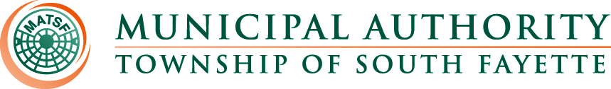

AGENDA

Meeting of November 7th, 2024

Roll Call:

Pledge of Allegiance:

Approval of Minutes from October 3rd, meeting

Public Comment:

Field Operations Report

- Review monthly field report for November.

Administrative Report:

- PAWC had a cyber-attack on their files.
- Liwhap Program
- Tammy MEIT
- Vector – 5% $59.27 to $62.24
- January Meeting
- Christmas Party Dec 1
- NCR/JET pay Credit Cards
- Pumps at Main Pump Station.
- Miller Run bridge by Reed St. bridge replacement project.
- Draft Budget tables for 2025.
- Lining Project for 2024 is complete.
- Replacing Air Relief Valve on the Oakdale force main.
- Apex Newbury update.
- Motion to approve the purchase of two trucks from Colussy Chevrolet under COSTARS.

Engineer’s Report:

- Motion to approve advertising for bids to have the new generator installed at the Main Pump Station.
- Motion to approve amending the rules and regulations for backfill materials under traveled surfaces.
- Motion to approve amending the rules and regulations to add a fee for review of new developments.
- Motion to pass Resolution 238 to apply for the State LSA program grant.

Solicitor’s Report:

Old Business:

- Hastings Phase 4 sewer line repairs.

New Business:

Meetings, Conferences and Training:

- The Operations Manager is actively participating in monthly 3RWW meetings at Greentree Borough pertaining to municipal Consent Order compliance.
- WWett25 show at the Indiana Convention Center in Indianapolis Indiana on February 17th to the 20th.
- PennTec 2025 June 22-25, at Kalahari Resort and Convention Center Pocono Manor.
- The Operations Manager and Field crew all attended the Annual 3 Rivers Wet Weather Sewer Conference in Monroeville PA.
Motion for Approval of Bills:

Bills – November 2024
- Checks
- ACH Payments
- Credit Card Purchases

Financial Statements:

Motion for Executive Session: Personnel

Adjournment

