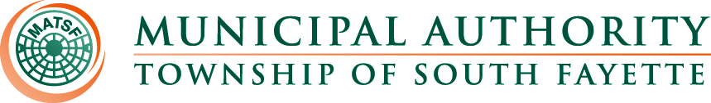

AGENDA

Meeting of December 5th, 2024

Roll Call:

Pledge of Allegiance:

Approval of Minutes from November 7th, meeting

Public Comment:

Field Operations Report

- Review monthly field report for November.
- Apex Apartments update.
- New trucks are both in services and all work complete by Xtreme Car and Truck.

Administrative Report:

- NCR/JET pay Credit Cards
- Motion for Adoption of 2025 Budget
- Motion for Adoption of Resolution 239 for update to sewer rates/fees for 2025
- Motion for Adoption of Resolution 240 to pass along all credit card and ACH fees to the customers.

Engineer’s Report:

Solicitor’s Report:

Old Business:

New Business:

Meetings, Conferences and Training:

- The Operations Manager is actively participating in monthly 3RWW meetings at Greentree Borough pertaining to municipal Consent Order compliance.
- PennTec 2025 June 22-25, at Kalahari Resort and Convention Center Pocono Manor.
- Office Manager participated in webinar Dec. 4, 2024, about proven strategies to increase delinquent collections and navigate bankruptcy, also participated in PLGIT 2024 Webinar Series - PLGIT and LGIP Basics: Everything You Need to know.

Motion for Approval of Bills:

Bills – November 2024
- Checks
- ACH Payments
- Credit Card Purchases

Financial Statements:

Motion for Executive Session: Personnel

Adjournment

