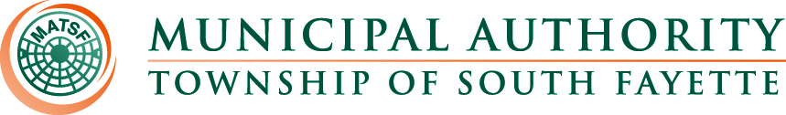

Minutes

Meeting of December 5th, 2024

Roll Call: Fred Cardillo, Kenneth Chambon, John Alan Kosky, Robert Zedreck and Glenn Davis.

Pledge of Allegiance:

The meeting was called to order by John Alan Kosky, Chairman. Board members present were Kenneth Chambon, Robert Zedreck, Glenn Davis, and Fred Cardillo. Also, present were Nick Goettman; Operations Manager; Romel Nicholas, Solicitor; Robert Horvat, Engineer; Jamie Summers, Recording Secretary.

Approval of Minutes from November 7th, meeting

MOTION to approve the Minutes of the meeting from November 7, 2024, made by Glenn Davis, seconded by Fred Cardillo, all members present voting AYE.

Public Comment:

Field Operations Report

- Reviewed monthly field report for November.
- Apex Apartments update.
- New trucks are both in services and all work complete by Xtreme Car and Truck.

Administrative Report:

- NCR/JET pay Credit Cards
- Motion for Adoption of 2025 Budget

MOTION to adopt the 2025 Budget was made by Kenneth Chambon, seconded by Fred Cardillo, all members present voting AYE.

- Motion for Adoption of Resolution 239 for update to sewer rates/fees for 2025

MOTION to adopt the Resolution 239 to update sewer rates/fees for 2025
was made by Robert Zedreck, seconded by Kenneth Chambon, all members present voting AYE.

- Motion for Adoption of Resolution 240 to pass along all credit card and ACH return fees to the customers.

MOTION to adopt Resolution 240 to pass along all credit/debit card fees along with NSF return check /ACH return fees to the customer was made by Fred Cardillo, seconded by Glenn Davis, all members present voting AYE.

Engineer’s Report:

Solicitor’s Report:

Old Business:

New Business:

Meetings, Conferences and Training:

- The Operations Manager is actively participating in monthly 3RWW meetings at Greentree Borough pertaining to municipal Consent Order compliance.
- PennTec 2025 June 22-25, at Kalahari Resort and Convention Center Pocono Manor.
- Office Manager participated in webinar Dec. 4, 2024, about proven strategies to increase delinquent collections and navigate bankruptcy, also participated in PLGIT 2024 Webinar Series - PLGIT and LGIP Basics: Everything You Need to know.

Motion for Approval of Bills:

Bills – December 2024
- Checks
- ACH Payments
- Credit Card Purchases

MOTION to approve the December 2024 bills for payment made by Fred Cardillo, seconded by Robert Zedreck, all members present voting AYE.

Financial Statements: were reviewed.

Motion for Executive Session: Personnel

MOTION to enter Executive Session 4:31 p.m. for Personnel Matters was made by Glenn Davis, seconded by Fred Cardillo, all member present voting AYE.

The Board came out of executive session at 5:06 p.m.

Adjournment

MOTION to adjourn at 5:06 p.m. made by Glenn Davis, seconded by Fred Cardillo, all members present voting AYE.

