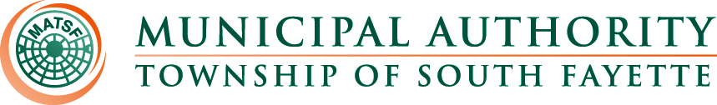

AGENDA

Meeting of January 2nd, 2025

Roll Call:

Pledge of Allegiance:

Approval of Minutes from December 5th, meeting

Reorganization:

- Motion to approve officers for 2025.
- Motion to retain KLH Engineers and GTN Law.
  - 2025 rates were received in correspondence from both KLH Engineers and GTN Law.

Public Comment:

Field Operations Report

- Review monthly field report for December.
- Bass Pro Shops Update.
- Main Pump Station pump getting repaired.
- Apex Newbury update

Administrative Report:

- Worked on insert for upcoming change credit card fee.
- Reviewed billing and insert with Muni-Link and SmartBill.
- Getting ready for delinquency review.

Engineer’s Report:

Solicitor’s Report:

Old Business:

New Business:

Meetings, Conferences and Training:

- The Operations Manager is actively participating in monthly 3RWW meetings at Greentree Borough pertaining to municipal Consent Order compliance.
- The Operations Manager participated in the first Allegheny Utility Coordinating Committee meeting that will be held once a quarter.
- Board Member Training March 20, 2025 DoubleTree by Hilton Pittsburgh Cranberry.
- PennTec 2025 June 22-25, at Kalahari Resort and Convention Center Pocono Manor.

Motion for Approval of Bills:

Bills – December 2024
- Checks
- ACH Payments
- Credit Card Purchases

Financial Statements:

Motion for Executive Session:

Adjournment

