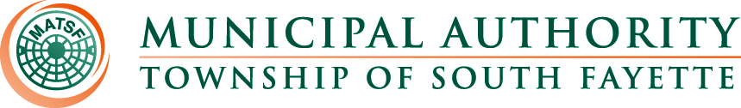

AGENDA

Meeting of February 6th, 2025

Roll Call:

Pledge of Allegiance:

Approval of Minutes from January 2nd, meeting

Public Comment:

Field Operations Report

- Review monthly field report for January.
- Oakdale pump station generator.
- Apex Newbury Update.
- 2024 Waste management reports complete and submitted for Robinson Run and Chartiers Creek.
- 2024 Cap Cost Certificate No. 22 was completed and submitted.
- Motion to approve the developer’s agreement for Bass Pro pending Solicitor and Managers final approval.

Administrative Report:

- MEIT-CVS Pharmacy
- Website Updates
- Approximately 578 delinquent notices were sent to customers. The notices required that the delinquent portion of the sewage bill be paid by February 20th to avoid door posting and associated fees.
- Worked with NCR – Jet pay credit cards.
- Auditor proposal.
- Dollar Energy Fund $45.00 to now $50.00 a quarter.

Engineer’s Report:

- Motion to award Chartiers Creek Pump Station Generator install 2024-01 based on bid results and recommendations to Merit Electrical Group Inc. for $78,400

Solicitor’s Report:
- Motion to approve resolution 241 to update the rules and regulation.
- Motion to approve resolution 242 adopting and providing a fee schedule.

Old Business:

New Business:

Meetings, Conferences and Training:

- The Operations Manager is actively participating in monthly 3RWW meetings at Greentree Borough pertaining to municipal Consent Order compliance.
- Board Member Training March 20, 2025 DoubleTree by Hilton Pittsburgh Cranberry.
- PennTec 2025 June 22-25, at Kalahari Resort and Convention Center Pocono Manor.

Motion for Approval of Bills:

Bills – January 2025
- Checks
- ACH Payments
- Credit Card Purchases

Financial Statements:

Motion for Executive Session:

Adjournment

