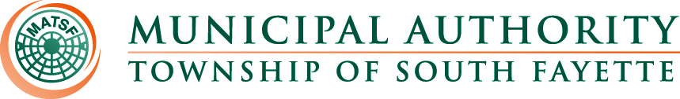

MINUTES

Meeting of January 2nd, 2025

Roll Call: Fred Cardillo, John Alan Kosky, Robert Zedreck & Glenn Davis.

The meeting was called to order by John Alan Kosky, Chairman. Board members present were Glenn Davis, Robert Zedreck and Fred Cardillo. Also, present were Nick Goettman; Operations Manager; Sam Gibson, Engineer; Romel Nicholas, Solicitor; Jamie Summers, Recording Secretary.

Pledge of Allegiance:

Approval of Minutes from December 5th, meeting

MOTION to approve the Minutes of the meeting from December 5, 2024. was made by Fred Cardillo, seconded by Glenn Davis, all members present voting AYE.

Reorganization:

- Motion to approve officers for 2025.

MOTION to approve officers for 2025 was made Glenn Davis, seconded by Fred Cardillo all members present voting AYE. John Alan Kosky, Chairman, Robert Zedreck, Vice Chairman, Fred Cardillo, Secretary, Glenn Davis, Treasurer and Bryan Muraco, Assistant Secretary Treasurer.

- Motion to retain KLH Engineers and GTN Law.
  - 2025 rates were received in correspondence from both KLH Engineers and GTN Law.

MOTION for confirmation of continued retention of KLH Engineers and GTN Law was made by Robert Zedreck, seconded by Glenn Davis all members present voting AYE.

Public Comment: NONE

Field Operations Report

- Reviewed monthly field report for December.
- Bass Pro Shops Update.
- Main Pump Station pump getting repaired.
- Apex Newbury update

Administrative Report:

- Worked on insert for upcoming change credit card fee.
- Reviewed billing and insert with Muni-Link and SmartBill.
- Getting ready for delinquency review.

Engineer’s Report:

Solicitor’s Report:

Old Business:

New Business:

Meetings, Conferences and Training:

- The Operations Manager is actively participating in monthly 3RWW meetings at Greentree Borough pertaining to municipal Consent Order compliance.
- The Operations Manager participated in the first Allegheny Utility Coordinating Committee meeting that will be held once a quarter.
- Board Member Training March 20, 2025, DoubleTree by Hilton Pittsburgh Cranberry.
- PennTec 2025 June 22-25, at Kalahari Resort and Convention Center Pocono Manor.

Motion for Approval of Bills:

Bills – December 2024
- Checks
- ACH Payments
- Credit Card Purchases
MOTION to approve the December 2024 bills for payment made by Glenn Davis, seconded by Fred Cardillo, all members present voting AYE.

Financial Statements: were reviewed.

Motion for Executive Session:

Adjournment:

MOTION to adjourn at 5:10 p.m. made by Robert Zedreck, seconded by Glenn Davis, all members present voting AYE.

