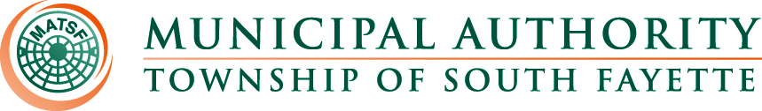

MINUTES

Meeting of March 6th, 2025

Roll Call: John Alan Kosky, Robert Zedreck, Glenn Davis, Fred Cardillo & Bryan Muraco.

Pledge of Allegiance:

The meeting was called to order by John Alan Kosky, Chairman. Board members present were Robert Zedreck, Glenn Davis, Fred Cardillo & Bryan Muraco. Also, present were Nick Goettman; Operations Manager; Sam Gibson, Engineer; Romel Nicholas, Solicitor; Jamie Summers, Recording Secretary.

Approval of Minutes from February 6th, meeting

MOTION to approve the Minutes of the meeting from February 6, 2025. was made by Fred Cardillo, seconded by Robert Zedreck Davis, all members present voting AYE.

Public Comment:

Field Operations Report

- Reviewed monthly field report for February.
- Oakdale pump station generator.
- Manhole repair on Route 50 in front of Children’s Hospital South.
- Watched Safety videos from MRM Optimus Risk Services with field staff.
- Apex Newbury pipe sag under retaining wall.

Administrative Report:

- 578 late notices were sent to customers. Currently, we are down to 172 for Door Postings.
- Motion to approve Hosack, Specht, Muetzel & Wood LLP proposal for continuing audit services.

MOTION to approve Hosack, Specht, Muetzel & Wood LLP proposal for continuing audit services was made by Robert Zedreck, seconded by Glenn Davis, all members present voting AYE.

Engineer’s Report:

Solicitor’s Report:
- Motion to execute the Operation and Maintenance Agreement with Hastings for Phase 4.

MOTION to execute the Operation and Maintenance Agreement with Hastings for Phase 4 was made by Fred Cardillo, seconded by Brian Muraco, all members present voting AYE.

Old Business:

New Business:

Meetings, Conferences and Training:

- The Operations Manager is attending monthly 3RWW meetings at Greentree Borough pertaining to municipal Consent Order compliance.
- Board Member Training March 20, 2025, DoubleTree by Hilton Pittsburgh Cranberry.
- PennTec 2025 June 22-25, at Kalahari Resort and Convention Center Pocono Manor.

Motion for Approval of Bills:

Bills – February 2025
- Checks
- ACH Payments
- Credit Card Purchases

MOTION to approve the February 2025 bills for payment made by Robert Zedreck, seconded by Glenn Davis, all members present voting AYE.

Financial Statements: were reviewed.

Motion for Executive Session:

Adjournment

MOTION to adjourn at 5:11 p.m. made by Brian Muraco, seconded by Glenn Davis, all members present voting AYE.

