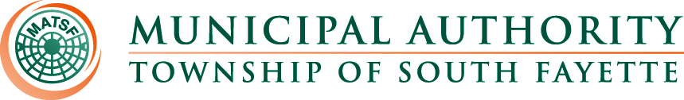

AGENDA

Meeting of June 5th, 2025

Roll Call:

Pledge of Allegiance:

Approval of Minutes from May 1st, meeting

Public Comment:

- Eric Newhouse
- Darryl Schulz

Field Operations Report

- Review monthly field report for May.
- Generator at Main Pump Station update.
- 1012 Stonegate Easement encroachment
- Stonegate Phase 3-5.

Administrative Report:

- Worked with Verizon for updates to equipment & better rate.
- 121 customers’ doors were posted for the 2nd round of delinquencies.
Sent over 16 customers for shutoff and 3 paid so far. (13 left as of today).
- Reviewing updates to Liens.
- Scheduling Audit.

Engineer’s Report:

Solicitor’s Report:

Old Business:

- Newbury Market sewer lines.

New Business:

Meetings, Conferences and Training:

- The Operations Manager is attending monthly 3RWW meetings at Greentree Borough pertaining to municipal Consent Order compliance.
- PennTec 2025 June 22-25, at Kalahari Resort and Convention Center Pocono Manor.
- Riley and Eric are taking the Wastewater General Exam Prep class for the next 8 weeks and going to sign up to take the wastewater exam on July 23rd in New Kensington, PA.

Motion for Approval of Bills:

Bills – May 2025
- Checks
- ACH Payments
- Credit Card Purchases

Financial Statements:

Motion for Executive Session:

Adjournment

